

Test Automation

Experiment 4 + 5

FastAPI

Submited by : Submited to :

Akhand Pratap Singh Mr. Alind

**Step 1**: Activate environment:



**Step 2**: Install FastAPI in activated environment

**Command :** **conda install -c conda-forge fastapi**

**conda install -c "conda-forge/label/cf202003" fastapi**

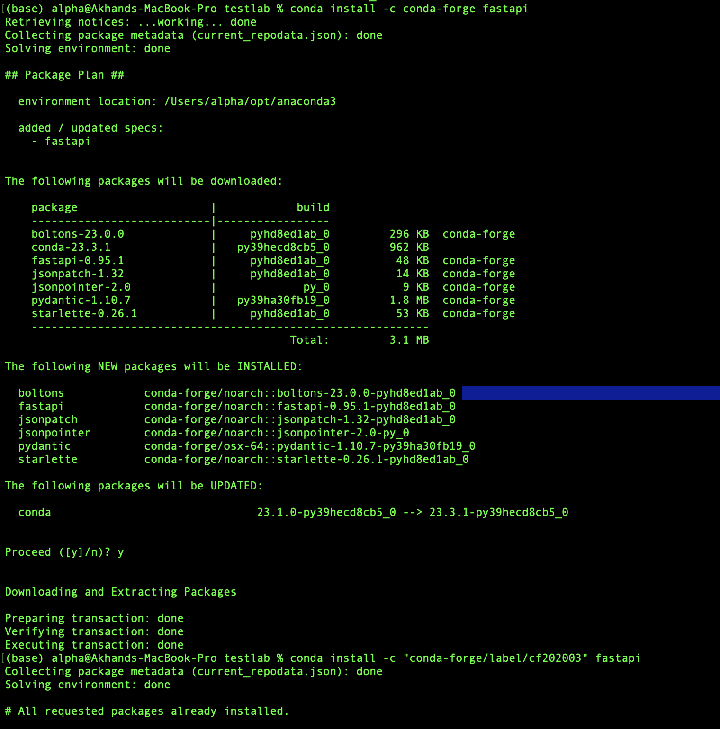

**Step 3**: write code to access fastAPI

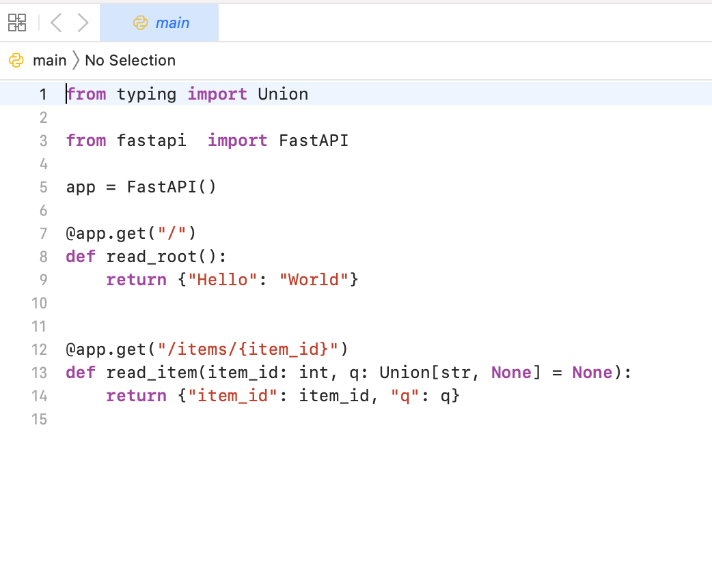

**Step 4**: Write test function for finding Prime number

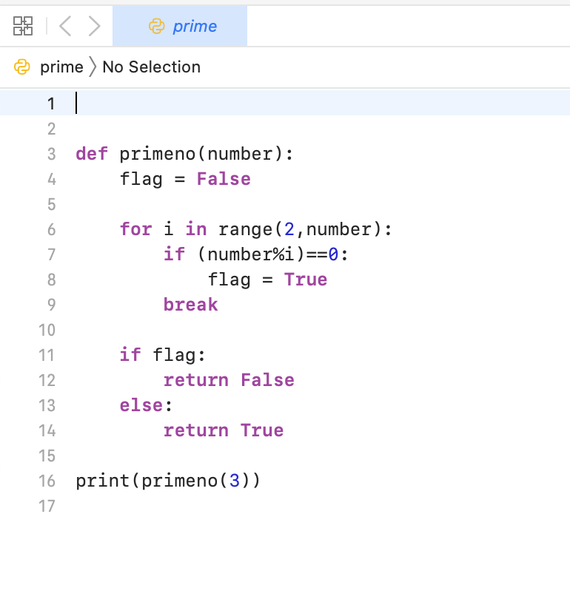

**Step 5**: Run the above script.

